Factor Analysis

Notes
Output Created |  | 28-JUN-2021 13:54:40
Comments
Input | Data | /Users/coderlax/Desktop/EO Hackathon/Asia/Quality of Life/COVID/Zscore/Z3.sav
Input | Active Dataset | DataSet6
Input | Filter | <none>
Input | Weight | <none>
Input | Split File | <none>
Input | N of Rows in Working Data File | 92
Missing Value Handling | Definition of Missing | MISSING=EXCLUDE: User-defined missing values are treated as missing.
Missing Value Handling | Cases Used | LISTWISE: Statistics are based on cases with no missing values for any variable used.
Syntax |  | FACTOR  /VARIABLES ZConfirmed ZRecovered ZDeadth  /MISSING LISTWISE  /ANALYSIS ZConfirmed ZRecovered ZDeadth  /PRINT UNIVARIATE INITIAL CORRELATION KMO EXTRACTION ROTATION  /FORMAT SORT  /PLOT EIGEN  /CRITERIA FACTORS(3) ITERATE(25)  /EXTRACTION PC  /CRITERIA ITERATE(25)  /ROTATION VARIMAX  /METHOD=COVARIANCE.
Resources | Processor Time | 00:00:00.16
Resources | Elapsed Time | 00:00:00.00
Resources | Maximum Memory Required | 1984 (1.938K) bytes

Descriptive Statistics
 | Mean | Std. Deviation | Analysis N
ZConfirmed | 2.18665000 | .999999836 | 92
ZRecovered | 1.97765615 | 1.000000104 | 92
ZDeadth | 1.70553011 | 1.000000227 | 92

Correlation Matrix
 |  | ZConfirmed | ZRecovered | ZDeadth
Correlation | ZConfirmed | 1.000 | .997 | .989
Correlation | ZRecovered | .997 | 1.000 | .995
Correlation | ZDeadth | .989 | .995 | 1.000

KMO and Bartlett's Testª
Kaiser-Meyer-Olkin Measure of Sampling Adequacy. |  | .637
Bartlett's Test of Sphericity | Approx. Chi-Square | 892.448
Bartlett's Test of Sphericity | df | 3
Bartlett's Test of Sphericity | Sig. | <.001

a. Based on correlations

Communalities
 | Raw |  | Rescaled
 | Initial | Extraction | Initial | Extraction
ZConfirmed | 1.000 | 1.000 | 1.000 | 1.000
ZRecovered | 1.000 | 1.000 | 1.000 | 1.000
ZDeadth | 1.000 | 1.000 | 1.000 | 1.000

Extraction Method: Principal Component Analysis.

Total Variance Explained
 | Component | Initial Eigenvaluesª |  |  | Extraction Sums of Squared Loadings
 | Component | Total | % of Variance | Cumulative % | Total | % of Variance | Cumulative %
Raw | 1 | 2.987 | 99.574 | 99.574 | 2.987 | 99.574 | 99.574
Raw | 2 | .011 | .382 | 99.956 | .011 | .382 | 99.956
Raw | 3 | .001 | .044 | 100.000 | .001 | .044 | 100.000
Rescaled | 1 | 2.987 | 99.574 | 99.574 | 2.987 | 99.574 | 99.574
Rescaled | 2 | .011 | .382 | 99.956 | .011 | .382 | 99.956
Rescaled | 3 | .001 | .044 | 100.000 | .001 | .044 | 100.000

Total Variance Explained
 | Component | Rotation Sums of Squared Loadings
 | Component | Total | % of Variance | Cumulative %
Raw | 1 | 1.516 | 50.518 | 50.518
Raw | 2 | 1.481 | 49.374 | 99.892
Raw | 3 | .003 | .108 | 100.000
Rescaled | 1 | 1.516 | 50.518 | 50.518
Rescaled | 2 | 1.481 | 49.374 | 99.892
Rescaled | 3 | .003 | .108 | 100.000

Extraction Method: Principal Component Analysis.
a. When analyzing a covariance matrix, the initial eigenvalues are the same across the raw and rescaled solution.

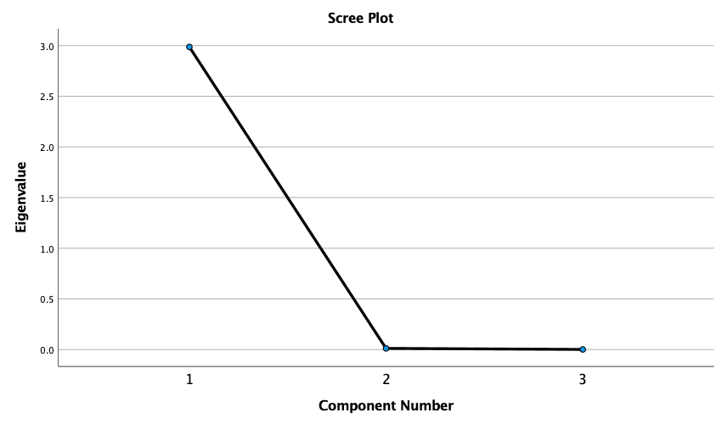

Component Matrixª
 | Raw |  |  | Rescaled
 | Component |  |  | Component
 | 1 | 2 | 3 | 1 | 2 | 3
ZRecovered | 1.000 | -.008 | -.029 | 1.000 | -.008 | -.029
ZConfirmed | .997 | -.071 | .017 | .997 | -.071 | .017
ZDeadth | .997 | .080 | .012 | .997 | .080 | .012

Extraction Method: Principal Component Analysis.ª
a. 3 components extracted.

Rotated Component Matrixª
 | Raw |  |  | Rescaled
 | Component |  |  | Component
 | 1 | 2 | 3 | 1 | 2 | 3
ZConfirmed | .759 | .651 | .008 | .759 | .651 | .008
ZRecovered | .716 | .696 | .055 | .716 | .696 | .055
ZDeadth | .653 | .757 | .013 | .653 | .757 | .013

Extraction Method: Principal Component Analysis.
Rotation Method: Varimax with Kaiser Normalization.ª
a. Rotation converged in 3 iterations.

Component Transformation Matrix
Component | 1 | 2 | 3
1 | .711 | .703 | .025
2 | -.703 | .711 | .000
3 | .018 | .018 | -1.000

Extraction Method: Principal Component Analysis.
Rotation Method: Varimax with Kaiser Normalization.

